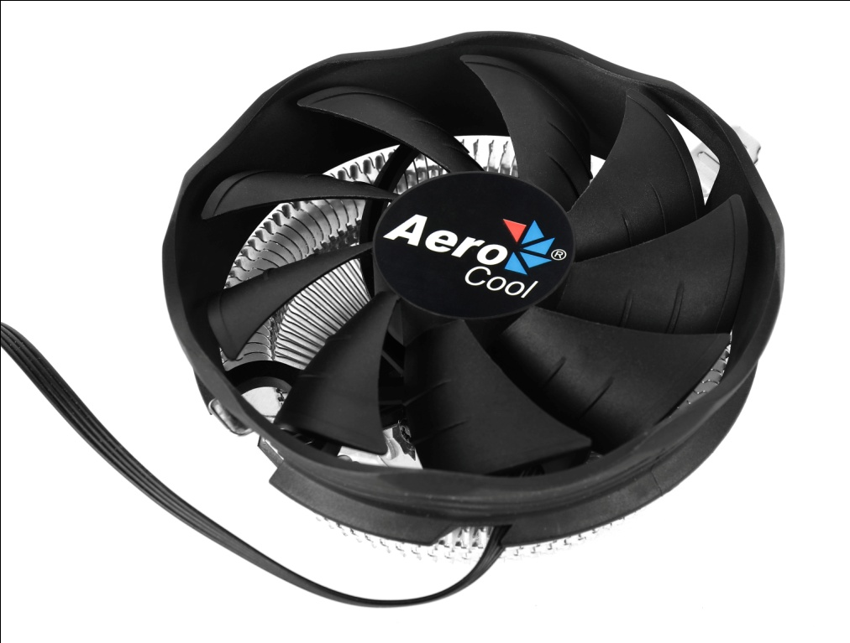

Product Overview:
Capable of mounting single 120mm fan configurations. PWM air cooling solution equipped with high efficiency fins and compact profile. Compatible with most current motherboard designs. Not compatible with Intel 2011 and 2066.
Specifications

Model |  | Verkho Plus
Base Material |  | Aluminum
Dimension |  | 128 x 128 x 68mm
TDP(Thermal Design Power) |  | 110
Fan | Speed | 1000-2000 rpm
 | Connector | PWM 4-Pin
 | Dimension | 120 x 120 x 25mm
 | Bearing Type | Hydraulic Bearing
 | Started Voltage | 6V
 | Rated Voltage | 12V
 | Rated Current | 0.25 A
 | Power Consumption | 3.0 Watts
 | Air Pressure | 0.48-1.19 mm-H2O
 | Air Flow | 29.45-57.23 CFM
 | Noise | 10.4-26.5dBA
 | MTBF  (Mean Time Before Failure) | 60000 hrs.
Socket |  | LGA 1156/1155/1151/1150/775 AM4/AM3+/AM3/AM2+/AM2/FM2/FM1

Warranty

1 year

Features
- TDP (Thermal Design Power) up to 110W.
- Upgraded high efficiency fins for maximum thermal performance.
- Compact profile capable of mounting single 120mm fan configurations; works with most current AMD and Intel motherboard designs. Not compatible with Intel 2011 and 2066.

Package Information

Product Name | Product Number | EAN CODE | UPC CODE
Verkho Plus | ACTC-NA30020.01 | 4710700950814
Carton Size ( L x W x H ) | 535 x 405 x 394 mm | Carton Weight | N.W 15.4 kg / G.W 16.6 kg
Retail Box Size ( L x W x H ) | 130 x 130 x 88 mm | Retail Box Weight | N.W 172 g / G.W 320 g
Carton Qty | 48 pcs | Pallet Qty | 960(GP)/1152 (HQ)

